Name: Ragib Ahsan

Frequentist Concepts Assignment

**Q1_Answer:**

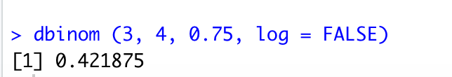

**Q2_Answer:**



**Q3_Answer:**



**Q4_Answer:**



**Q5_Answer:**



**Q6_Answer:**

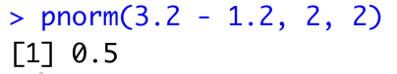

**Q7_Answer:**

I choose 3 and 1.5 for α and β respectively to get a skewed beta distribution. I repeatedly press the sample button and the resulted histogram shape I got was left-skewed. First few sample count percentages changed with a large difference but then the percentage count changed gradually.

**Q8_Answer:**

Keeping the same values of α and β as question 7, and with the sample size 2, initially with fewer clicks (4-5 times) on the sample button, I observed that, the histogram shape was as bell-shaped but as I increase the click on the sample button, the samples became more distributed and the histogram shape shifted towards uniform like.

**Q9_Answer:**

I kept the same values again (same values as question 7 and 8) with sample size 15, the shape of the histogram was normal initially but as increased the click on the sample button, the shaped shifted towards uniform like. Also, in this case, I have observed the bar numbers in the histogram were less than previous two.

**Q10_Answer:**

I would say, the more the sample size the more accurate estimation of the mean of the calculation- precise result from the data and decrease the variations.

**Q11_Answer:**

The sample size and the standard deviation are the two main factors here. With the increased sample, we can get more precisely estimated mean of the data with less variation- reduced standard deviation will reduce the width of bell-shaped curve.

**Q12_Answer:**

253🡪 (25 x 25 x 25) = 15, 625

So, the possible 3- character words = 15, 625 (by following the 2-character words example)

**Q13_Answer:**

Pages = 410

Rows per page = 40

Positions per row = 80, with one additional position it would be 80+1 = 81

410 x 40 x 81 = 1,328,400 🡪 251,328,400